A000-Xian-Egyptian-Coptic Cross- Dark Brown Wood-4th c CE

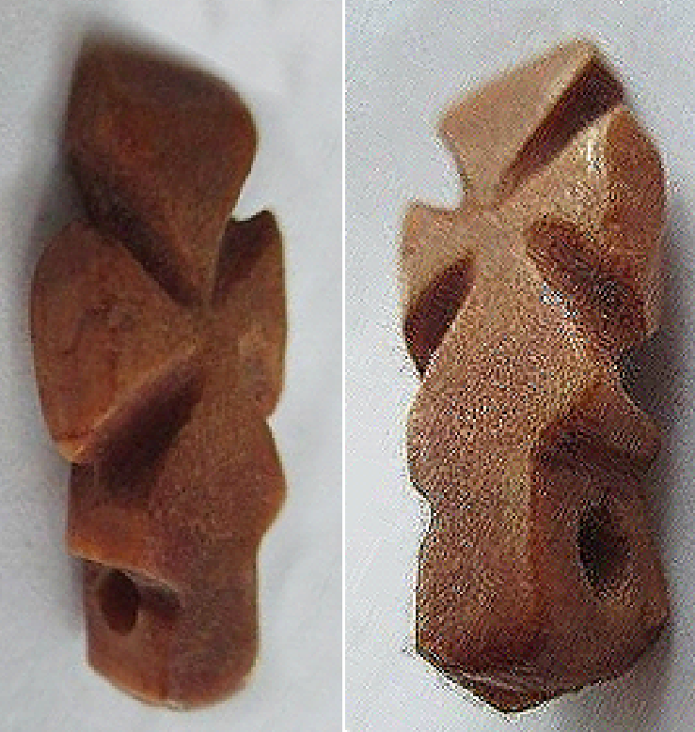

Figs. 1-2. Egyptian-Coptic Cross-Dark Brown Wood-4th c CE

**Case No.: 4**

**Accession No.**

**Formal Label:** Egyptian-Coptic Cross with Concentric Circle-Wood-4th c CE

**Display Description:**

Egyptian-Coptic wood reliquary cross, 4th c CE. This cross was made of reliquary wood ostensibly from the original cross and, as such, it was believed to have inhered in it the possibility to work miracles on the believers, just as the cross had worked miracles for Jesus’ resurrection. Egyptian Coptic crosses were a fusion of the Orthodox Christian cross and the pagan Egyptian ankh **☥**. The Orthodox cross was constructed with four equi-sized triangular elements, one for the head, two for the outstretched arms and body, and a third for the feet. Together these three registers represent the non-representational resurrected god. Below these was a short plinth or handle that represented the lower portion of the Egyptian ankh. Therefore, this cross was a hybrid incorporating the traditional, autochthonous ankh on which was superimposed four equi-sized triangular elements. In effect, this fusion enabled the local Egyptian populace to continue to worship their symbol of life, the ankh, simultaneously with the abstract image of a resurrected god.

**Accession Number:**

**LC Classification:** BX133.3

**Date or Time Horizon:**

**Geographical Area:** Lower Egypt

**Map:**



**GPS coordinates:** 31.31298 30.05882

**Cultural Affiliation:** Coptic Christian

**Media:** wood from Jesus’ cross (reliquary) and black carbon pigment.

**Dimensions:** H 20 mm

**Weight:**

**Condition:** Well carved. Dark brown patina

**Provenance:** Ex H. Sakr collection, London, acquired 1960's.

**Discussion:**

The Coptic Church had been established by Saint Mark in the first or third year of the reign of Emperor Claudius, i.e. 41 or 43 CE, according to Eusebius of Caesarea (260/265 – 339/340 CE) in his *Ecclesiastical History*. These crosses represent the very first attempt to symbolize Jesus as an abstract, iconic divine being, by refusing to portray him as a human figure. This may reflect the Coptic Church’s opposition to the Arian party that regarded Jesus as a purely human prophet.

This ankh-cross was carved in three registers: an upper register representing the head of the savior, a middle register representing his outstretched arms and body, and a lower, downward slanting register his feet. The plinth at the bottom represents the lower part of the Egyptian ankh which forms its “handle”.

These crosses date to a time no earlier than the Council of Nicaea, 325 CE, when the earliest Christian crosses have been dated in controlled archaeological settings and when the concept of a resurrected human-divinity was established theologically by the Nicene Creed under the guidance of Constantine. The elevation of Jesus to this position of divinity reflected Constantine’s effort to achieve a religion that would surpass all of the other so-called “pagan” cults in its ineffability. Politically, this reflected Constantine’s effort to solidify the two halves of his empire, western Roman Latin and Eastern Hellenistic Greek. Economically, this reflected Constantine’s effort to gain control of all the monetary and real estate holdings of the traditional cults under one roof in order to be able to continue to fund his armies and to fund the hitherto inadequately funded agencies of health, education and welfare under the aegis of Christianity, both East and West.

**References:**

Bagnall, Roger. 1993. *Egypt in Late Antiquity.*Princeton: Princeton University Press.

Bell, H. Idris. 1944. "Evidences of Christianity During the Roman Period." *Harvard Theological Review* 37: 185-208.

Griggs, C. Wilfred. 1993. *Early Egyptian Christianity: from its Origins to 451 C.E.* Leiden: Brill.

Haas, Christopher. 1997. *Alexandria in Late Antiquity*. Baltimore: Johns Hopkins University Press.

Horn, Jürgen. 1986. *Studien zu den Märtyrern des nördlichen Oberägypten. I. Märtyrerverehrung und Märtyrerlegende im Werke des Schenute*. Wiesbaden: Harrassowitz.

Horn, Jürgen. 1992. *Studien zu den Märtyrern des nördlichen Oberägypten II. Märtyrer und Heilige des XI. bis XIV. Oberägyptischen Gaues.* Wiesbaden: Harrassowitz.

Meinardus, Otto. 1977. *Christian Egypt, Ancient and Modern.*Cairo: American University Press. First edition 1965

Pearson, Birger A. and James E. Goehring. 1986. *The Roots of Egyptian Christianity.* Philadelphia: Fortress Press.